**Impact of Thromboxane Generation on Long-term Survival in Aspirin Users and Non-users**

Short Title: Thromboxane generation and survival

Jeffrey J. Rade MDa,c, Bruce A. Barton PhDa, Vasan S. Ramachandran MDc, Shari S. Kronsberg MSa, Vanessa Xanthakis, PhDb, John F. Keaney MDa,b, Naomi M. Hamburg MD, MScb, Nikolaos Kakouros, MD, PhDa and Thomas A. Kickler MDc.

From the aUniversity of Massachusetts Medical School, Worcester, MA, bBoston University School of Medicine, Boston, MA and cJohns Hopkins School of Medicine, Baltimore, MD

Correspondence to: Jeffrey J. Rade, MD, Division of Cardiology, University of Massachusetts Medical School, 55 Lake Avenue North, Worcester, MA 01655. Phone: (774) 441-6310. Fax: (774) 441-6303. Email: jeffrey.rade@umassmed.edu

Word Count:

**ABSTRACT**

**BACKGROUND:** Persistent systemic thromboxane A2 (TXA2) generation in aspirin (ASA) users with cardiovascular disease (CVD), originating predominantly from non-platelet sources, is associated with adverse clinical outcome, including mortality. The mortality risk associated with systemic TXA2 generation in non-ASA users or individuals without established CVD are unknown.

**METHODS:** Systemic TXA2 generation was assessed by measuring its stable metabolites (TXB2-M) in banked urine samples by ELISA obtained from 3044 subjects (mean age 66 ± 9 years) of the Offspring and Omni cohorts of the Framingham Heart Study who participated in examinations 8 and 3, respectively. Multivariable modeling was performed to determine the impact of TXB2-M on survival over a median observation period of 11.9 years (IQR, 10.6, 12.7 years) and to identify clinical and laboratory variables associated with systemic TXA2 generation in subjects stratified by ASA use.

**RESULTS:**  Of the 1363 subjects (44.8%) taking ASA at the index examinations, median TXB2-M was expectedly significantly lower than in the ASA non-users (1147 vs 4179 pg/mg creatinine, P <0.0001). TXB2-M was significantly associated with decreased long-term survival irrespective of ASA use, with hazard ratios for all-cause, cardiovascular and cancer mortality of 2.14, (95% CI, 1.84-2.48), 3.09 (95% CI, 2.18-4.38) and 1.88 (95% CI, 1.45-2.43), respectively (P <0.0001 for all) for TXB2-M in the upper two quartiles for ASA users and upper quartile for ASA non-users compared to lower quartiles. TXB2-M was associated with all-cause mortality irrespective of the presence or absence of established CVD in both ASA users and non-users and predicted mortality after adjustment for age and gender (OR 1.79, 95% CI, 1.47-2.18, P <0.0001) as well as multiple known mortality risk factors for similarly aged populations (OR 1.73, 95% CI, 1.39-2.15, P <0.0001). Renal function, age, gender, smoking and oxidative stress were among the major determinants of TXB2-M irrespective of ASA use. ASA dose was an additional major determinant in ASA users while HDL, NSAID and oral anticoagulant use were major determinants in ASA non-users.

**CONCLUSION:** Systemic TXA2 generation predicts long-term survival in an unselected cohort of older aged individuals irrespective of ASA use or presence of established cardiovascular disease.

**INTRODUCTION**

Thromboxane A2 (TXA2) is an eicosanoid with potent platelet activating and vasoconstrictor properties generated from the metabolism of arachidonic acid by the actions of cyclooxygenase (COX) and downstream thromboxane synthase enzymes {Patrono, 1990 #2408}. In healthy individuals, TXA2 generation is thought to occur mainly in platelets and is effectively inhibited by aspirin (ASA), which irreversibly inhibits COX-1.{Patrono, 2008 #2044} In contrast, patients with cardiovascular disease (CVD) generate substantial amounts of TXA2 in non-platelet tissues that is not fully suppressed by standard ASA therapy.{Kakouros, 2016 #2543}{Faraday, 2006 #1792}{Tantry, 2005 #2485}{Homorodi, 2016 #2614} Non-platelet TXA2 generation has been shown in several studies to be a novel predictor of adverse cardiovascular outcome and death, though the mechanism by which this occurs is not fully understood. {Eikelboom, 2002 #1106}{Eikelboom, 2008 #1747}{Gluckman, 2011 #2036}{Kakouros, 2017 #2835}{McCullough, 2017 #2823} It is not known if non-platelet TXA2 generation in individuals without established cardiovascular disease or if systemic TXA2 generation from combined platelet and non-platelet sources in non-ASA users also predicts adverse clinical outcome and mortality. It is also unclear if the stimuli for systemic TXA2 generation differ between ASA users and non-users.

To address these questions, we measured systemic non-renal TXA2 generation by quantifying stable metabolites of thromboxane B2 (TXB2-M){Catella, 1986 #2175}in the banked urine samples of subjects enrolled in the Offspring and Omni cohorts of the Framingham Heart Study and determined its relationship to long-term survival. To help identify differential stimuli for systemic TXA2 generation, we analyzed variables associated with systemic TXA2 generation in subjects stratified by ASA use at the time of the index examinations.

**METHODS**

The Framingham Heart Study is a longitudinal community-based study established in 1948 and comprised of several study cohorts with serial examinations every 4 to 8 years.{Mahmood, 2014 #2843} The study population for this analysis included subjects who attended examination 8 (2005-2008) of the Offspring and examination 3 (2007 to 2008) of the Omni cohorts in whom there was an available urine sample banked at the time of the examination.{Feinleib, 1975 #2446}{Splansky, 2007 #2845} Written informed consent was obtained by study participants at each examination and the study protocols were approved by the human subject institutional review boards of the Boston University School of Medicine and the University of Massachusetts Medical School.

TXB2-M was measured in banked urine samples stored at -80ºC in duplicate using the AspirinWorks® 11dhTXB2 Test Kit (CorgenixInc., Bromfield, CO) according to the manufacturer’s instruction and normalized to urine creatinine. The assay has a limit of detection of 156.25 pg/mL and a linear range of (300-4000 pg/mL). Samples were diluted 1:5 for the initial determination and those with values below the linear range were reported as 300 pg/mL, while those above the linear range were re-assayed at 1:20 dilution and reported as 4000 pg/mL if above the linear range. The intra-assay coefficient of variance was 3.3%. The stability of TXB2-M measurements in banked urine samples with this assay after long-term storage and multiple freeze-thaw cycles has previously been established in our laboratory.{Olson, 2012 #2359} Urine 8-iso-PGF2α , serum C-reactive protein (CRP), interleukin- 6 (IL-6), monocyte chemotactic protein (MCP), plasma P-selectin and lipoprotein-associated phospholipase A2 (Lp-PLA2) and other standard laboratory variables were previously been measured in these subjects as described{Keaney, 2003 #2323}{Fontes, 2013 #2846} with biomarker measurement manuals available on the FHS website at <http://www.framinghamheartstudy.org/share/vascularprotocols.html>.

Descriptive statistics were calculated in the usual way (Table 1) with ASA use defined based on review of medication at the time of the index examination. The frequency of categorical variables was compared between groups using the Pearson chi-square test. Means of continuous variables that were normally distributed based on Shapiro-Wilk test for normality and/or visual inspection were compared using Student’s t-test, while medians of non-normally distributed variables were compared using Wilcoxon rank sum test. Cox proportional hazards regression was used to model the relationship between TXB2-M and time to death (Table 2). TXB2-M was considered both as a continuous variable, after log-transformation, and as a binary variable of quartile groupings based on the results of the Kaplan-Meier survival plots (quartiles 1-2 versus 3-4 for ASA users and quartiles 1-3 versus 4 for ASA non-users). Hazard Ratios (HR) are reported for all-cause mortality and categories of death for ASA users, non-users and the combination (using combined quartile grouping) with associated p-value from Wald chi-square test. Multivariable logistic regression analysis was used to investigate the effect of TXB2-M (based on the above quartile groupings) on all-cause mortality when adjusted for other known predictors of mortality in similar demographic groups (Table 3), including: 1) none (Model 1); 2) age and gender (Model 2), and; 3) age, gender, mean arterial blood pressure, atrial fibrillation, LVEF, hemoglobin A1C and eGFR (Model 3). Odds ratios and 95% confidence intervals are reported with the associated p-value from Wald chi-square test. Multivariable modeling was used to define variables associated with TXB2-M using a standard general linear model (GLM). Univariate modeling of variables by ASA use was first conducted to determine the significance of the effect on lnTXB2-M (Supplement Table 1). For ASA users, an additional variable was added to adjust for the ASA dose (dichotomized as a weekly average of ≤ 81 versus >81 mg/day). Variables with a significant (p ≤ 0.05) effects on lnTXB2-M were then included in a full GLM and backward elimination of non-significant variables (p-value >0.05) was used to achieve the final parsimonious model (Table 4).

**RESULTS**

**Baseline Characteristics**

Of the3021 Offspring and 298 Omni 1 Cohort subjects who participated in examinations 8 and 3, TXB2-M could be measured in available urine samples from 3044 (91.7%) subjects. Of these subjects, 1363 (44.7%) were taking ASA at the time of the examination. Given that standard ASA therapy effectively suppresses platelet but not non-platelet TXA2 generation, median TXB2-M was expectedly lower in ASA users compared to non-users (Figure 1). The characteristics of subjects stratified by ASA use and in subjects without TXB2-M determination are shown in Table 1. Compared to ASA non-users, ASA users were older, with a higher body mass index, more likely to be male and have a higher prevalence of cardiovascular risk factors/established cardiovascular disease with associated medical therapy. Subjects in whom systemic TXA2 could not be assessed had characteristics that more closely resembled ASA users than non-users.

**Association of Systemic Thromboxane Generation with Long-term Survival**

Survival data was available for 3043 subjects (99.9%) in whom TXB2-M was measured, of whom 710 (23.0%) died during a median observation period of 11.9 years (IQR, 10.6, 12.7 years) from the index examination. Long-term survival was significantly lower in ASA users compared to non-users (Figure 2) and was significantly associated with the degree of systemic TXA2 generation irrespective of ASA use (Figures 3 and Supplement Figure 1). In both groups, systemic TXA2 generation was associated with increased mortality rates in all categories of death except stroke (Table 2) as well as in a wide array of subject subgroups, including those with and without established CVD (Supplement Figure 2). To understand the strength of association between systemic TXA2 generation and all-cause mortality, multivariable modeling was performed to adjust for known predictors of mortality in individuals of similar median age (Table 3). Systemic TXA2 generation remain predictive of all-cause mortality when adjusted for age and gender alone (Model 2) or in combination with known predictors of death from heart disease, stroke, diabetes and kidney disease (Model 3).

**Determinants of Systemic Thromboxane Generation**

Previous studies have identified age, gender and oxidative stress as major independent determinants of non-platelet TXA2 generation in ASA users with established cardiovascular disease, with ASA dose, race, lipid therapy, left ventricular ejection fraction and renal function being minor determinants.{Kakouros, 2016 #2544}{Eikelboom, 2008 #1747}{McCullough, 2016 #2824;McCullough, 2017 #2825}{McCullough, 2016 #2824}{Szczeklik, 2016 #2823} Multivariable modeling was performed to determine if these same variables were associated with TXA2 generation in an unselected population and if there were differences between ASA users and non-users. Supplement Table 1 shows univariate regression analyses of demographic and laboratory variables available at the time of the index examination. Multivariable modeling revealed that age, gender, oxidative stress and renal function were independently associated with TXA2 generation irrespective of ASA use, as were cigarette use and the inflammatory markers IL-6 and P-selectin (Table 4). ASA dose, diabetes, proteinuria and atrial fibrillation/flutter were independently associated with TXB2-M in ASA users while NSAID use, hypertension oral anticoagulant use and HDL were associated with TXB2-M in non-ASA users.

**DISCUSSION**

The major finding of this study is that systemic non-renal TXA2 generation is associated with increased risk of long-term all-cause mortality irrespective of ASA use or presence of established CVD and remains predictive after adjustment for other known mortality risk factors.

Persistent systemic TXA2 generation despite the use of ASA has emerged as a novel risk factor for adverse outcome and mortality in patients with CVD.{Eikelboom, 2002 #1106}{Eikelboom, 2008 #1747}{Gluckman, 2011 #2036}{Kakouros, 2017 #2835}{McCullough, 2017 #2823} While initially thought to be due to incomplete ASA-mediated suppression of platelet COX-1, it is now appreciated that daily ASA doses of 81-325 mg are quite effective at suppressing platelet TXA2 generation in the vast majority of individuals and that residual systemic TXA2 generation originates predominantly from non-platelet tissues.{Frelinger, 2006 #2568}{Kakouros, 2016 #2543}{Faraday, 2006 #1792}{Tantry, 2005 #2485}{Homorodi, 2016 #2614}{Patrignani, 2014 #2764} The circulating half-life of ASA is relatively short (~20 minutes) and unlike platelets, which lack the capacity to regenerate COX-1 irreversibly acetylated by ASA, nucleated cells can produce TXA2 following regeneration of COX-1 or by COX-2 that is not effectively inhibited by standard doses of ASA.{Widlansky, 2003 #2320} While standard ASA therapy does not fully suppress TXA2 generation in non-platelet tissue, the inverse association between TXB2-M and ASA dose suggests that there is at least a degree of partial suppression. It is therefore difficult to determine the relative proportion of generation from each compartment and possible that platelets may not be the dominant source of systemic TXA2 generation in some individuals.

Previous studies identifying an inverse association between systemic TXA2 generation and survival were mostly performed in ASA users with CVD. Ours is the largest study to measure systemic TXA2 generation in an unselected population and the first to identify equally strong associations with all-cause, CVD and cancer mortality in both ASA users and non-ASA. Most importantly, the association between systemic TXA2 generation and survival remained strong after adjustment for age and gender, alone and in combination with markers of cardiovascular disease, renal disease and diabetes that are predictive of mortality in similarly aged individuals. The association with all-cause mortality was further observed in a wide array of subgroups irrespective of ASA use, including those with and without established CVD at the time of the index examination. These findings strongly argue that non-platelet TXA2 generation is more than a marker of adverse outcome but plays a pathobiologic role in mediating disease that is potentially modifiable.

The mechanisms by which non-platelet TXA2 generation could mediate disease is not fully understood. TXA2 generation is most widely associated with platelet activation, both as an intracellular amplifier of activation in response to a number of physiologic agonists as well as a potent direct agonist that binds to extracellular thromboxane-prostanoid receptors (TPr) {Patrono, 1990 #2408}. However, evidence does not suggest that TXA2 generated in non-platelet tissue causes pathologic thrombosis by stimulating platelet activation. While non-platelet TXA2 generation is associated with an increased risk of early graft thrombosis after coronary artery bypass graft surgery, that risk was found to be independent of measures of platelet reactivity.{Gluckman, 2011 #2036} Most compelling, the risk of MACE associated with increased TXA2 generation in ASA users with CVD was not attenuated by the addition of the ADP-receptor antagonist clopidogrel.{Eikelboom, 2008 #1747} Through the activation of cellular thromboxane-prostanoid receptors (TPr), TXA2-mediated signaling elicits exerts a myriad of effects in non-platelet tissue, including vasoconstriction, fibrosis, inflammation, immune modulation and cancer progression. {Nakahata, 2008 #2763}{Feletou, 2010 #2423}{Ekambaram, 2011 #2847} These non-platelet effects

Previous studies revealed that systemic TXA2 generation in ASA users with CVD is highly associated with increased oxidative stress.{Kakouros, 2016 #2544}{McCullough, 2016 #2824;Vasudevan, 2016 #2826} The present study also found a strong correlation between urine 8-iso-PGF2α, both a marker and mediator of oxidative stress, and TXB2-M in both ASA users and non-users. Oxidative stress is intimately involved in the pathobiology of a wide array of human diseases, particularly endothelial dysfunction.{Widlansky, 2003 #2319} Endothelial dysfunction In vitro studies revealed that endothelial cells exposed to oxidative stress generate both 8-isoPGF2α and TXA2, and that 8-isoPGF2α can directly stimulate TXA2 generation via activation of the TXA2-prostanoid receptor (TPr). {Kakouros, 2016 #2544} There is growing evidence for TXA2 generation in various malignancies and microvascular TPr expressionand signalling have been impliocated in in has been signaling have been implicated in has in ecan wide array of human diseases and measurement of 8-isoPGF2a and other isoprostanes have as uch as CVD, renal disease, obesity, diabetes, cancer and aging in general.

In addition to finding an association between systemic TXA2 generation and cardiovascular death, we also observed an association with cancer death that was independent of ASA use.

There are several acknowledged limitations of our study. ASA use was able to be quantified at the time of the index examination and used to stratify subjects into those whose urine TXB2-M reflects predominantly non-platelet-TXA2 generation (ASA users) and those it reflects both platelet and non-platelet TXA2 generation (ASA non-users). Subsequent ASA use and therefore its potential impact on survival could not be determined. In a prior study of subjects with documented ASA-mediated inhibition of platelet TXA2 generation, we found that ASA dose was inversely correlated to TXB2-M, suggesting that ASA (and likely NSAIDs) exerts at least some suppressive effect on non-platelet TXA2 generation.{Kakouros, 2016 #2544} It is therefore impossible to know what proportion of TXA2 generation comes from platelets and non-platelet sources in ASA non-users.

The Offspring cohort of the Framingham Heart Study enrolled almost exclusively white individuals. While 298 subjects enrolled in the minority Omni cohort were included in our analysis, non-white subjects constituted <10% of the entire study population. Although previous studies have indicated that non-whites have higher levels of non-platelet TXA2 generation than whites, we could not adequately investigate the impact of race on outcome due to this skewed representation.

|  |  |  |  |  |
| --- | --- | --- | --- | --- |
| **Table 1.** Clinical and laboratory characteristics of subjects at index examination stratified by aspirin use. | | | |  |
| **Characteristic** | **ASA Users**  **(N = 1363)** | **ASA Non-users**  **(N = 1681)** | **P-value** | **Missing TXB2-M**  **(N=278)** |
| Age, mean (SD) | 68 (8) | 64 (9) | <0.0001 | 73 (10) |
| Female gender, n (%) | 604 (44.3) | 1033 (61.5) | <0.0001 | 212 (77.1) |
| Non-white race, n (%) | 84 (6.2) | 124 (7.5) | 0.1635 | 3 (1.1) |
| Hispanic ethnicity, n (%) | 34 (2.8) | 58 (3.9) | 0.1416 | 9 (3.9) |
| BMI (kg/m2), mean (SD) | 28.8 (5.4) | 28.0 (5.5) | <0.0001 | 28.4 (5.6) |
| eGFR (mL/min/1.73 m2), mean (SD) | 76.0 (16.8) | 81.0 (15.7) | <0.0001 | 71.4 (19.2) |
| Cigarette use, n (%) |  |  | 0.2472 |  |
| Current | 90 (6.6) | 138 (8.2) |  | 27 (9.8) |
| Former | 47 (3.5) | 54 (3.2) |  | 14 (5.1) |
| Never | 1221 (89.9) | 1489 (88.6) |  | 234 (85.1) |
| LVEF (%), mean (SD) | 65.8 (7.4) | 66.5 (6.2) | 0.0103 | 65.7 (7.7) |
| Atrial fibrillation/flutter rhythm on ECG, n (%) | 28 (2.1) | 44 (2.6) | 0.3093 | 9 (3.3) |
| Medical history of: |  |  |  |  |
| Hypertension, n (%) | 902 (66.2) | 628 (37.4) | <0.0001 | 169 (61.4) |
| Hyperlipidemia, n (%) | 822 (60.4) | 463 (27.6) | <0.0001 | 124 (45.3) |
| Diabetes, n (%) | 275 (20.3) | 162 (9.7) | <0.0001 | 41 (22.4) |
| Heart failure, n (%) | 39 (2.9) | 29 (1.7) | 0.0350 | 18 (6.6) |
| Myocardial infarction, n (%) | 205 (15.0) | 88 (5.2) | <0.0001 | 38 (13.8) |
| Atrial fibrillation/flutter, n (%) | 113 (8.3) | 96 (5.7) | 0.0051 | 32 (11.6) |
| Cerebrovascular disease, n (%) | 110 (8.1) | 97 (5.8) | 0.0577 | 41 (14.9) |
| Peripheral vascular disease, n (%) | 88 (6.5) | 42 (2.5) | <0.0001 | 26 (9.5) |
| Coronary revascularization, n (%) | 306 (22.5) | 83 (4.9) | <0.0001 | 38 (13.8) |
| PCI, n (%) | 203 (14.9) | 65 (3.9) | <0.0001 | 38 (13.8) |
| CABG surgery, n (%) | 155 (11.4) | 26 (1.6) | <0.0001 | 20 (7.3) |
| Valvular heart surgery, n (%) | 41 (3.0) | 19 (1.1) | 0.0002 | 10 (3.6) |
| COPD, n (%) | 104 (7.6) | 114 (6.8) | 0.3667 | 30 (10.9) |
| DVT/PE, n (%) | 21 (1.5) | 39 (2.3) | 0.1241 | 8 (2.9) |
| Cancer, n (%) | 489 (35.9) | 497 (29.6) | 0.0002 | 96 (34.9) |
| Medication use: |  |  |  |  |
| Aspirin dose >81 mg/d, n (%) | 353 (25.9) |  |  | 29/129 (22.5) |
| NSAID, n (%) | 315 (23.1) | 453 (27.0) | 0.0154 | 63 (22.9) |
| Antihypertensive therapy n (%) | 51 (3.7) | 35 (2.1) | 0.0060 | 6 (2.2) |
| Beta-blocker, n (%) | 540 (39.6) | 275 (16.4) | <0.0001 | 110 (40.0) |
| ACEi/ARB, n (%) | 622 (45.6) | 385 (22.9) | <0.0001 | 106 (38.6) |
| Lipid therapy, n (%) | 893 (65.5) | 578 (34.4) | <0.0001 | 131 (47.6) |
| Statin, n (%) | 776 (56.9) | 429 (25.5) | <0.0001 | 115 (41.8) |
| Non-statin, n (%) | 117 (8.6) | 149 (8.9) | 0.7858 | 16 (5.8) |
| Diuretic, n (%) | 423 (31.0) | 323 (19.2) | <0.0001 | 82 (29.8) |
| Insulin, n (%) | 38 (2.8) | 11 (0.7) | <0.0001 | 12 (4.4) |
| Non-insulin diabetic therapy, n (%) | 179 (13.1) | 103 (6.1) | <0.0001 | 24 (8.7) |
| Oral anticoagulant, n (%) | 52 (3.8) | 102 (6.1) | 0.0048 | 18 (6.6) |
| Laboratory data: |  |  |  |  |
| Serum creatinine (mg/dL), mean (SD) | 0.95 (0.30) | 0.88 (0.27) | <0.0001 | 1.00 (0.81) |
| Fasting plasma glucose (mg/dL) | 110 (27) | 104 (21) | <0.0001 | 105 (22) |
| Hemoglobin A1C (%), mean (SD) | 5.8 (0.8) | 5.7 (0.6) | <0.0001 | 5.8 (0.6) |
| Plasma lipid profile: |  |  |  |  |
| Total cholesterol (mg/dL), mean (SD) | 175 (36) | 195 (36) | <0.0001 | 186 (38) |
| LDL cholesterol (mg/dL), mean (SD) | 97 (30) | 112 (32) | <0.0001 | 104 (31) |
| HDL (mg/dL), mean (SD) | 55 (17) | 60 (18) | <0.0001 | 56 (17) |
| Triglyceride (mg/dL), mean (SD) | 119 (75) | 116 (68) | 0.2351 | 131 (67) |
| Serum CRP (mg/L), mean (SD) | 3.2 (7.4) | 3.4 (7.3) | 0.4580 | 4.2 (7.1) |
| Serum insulin (pmol/L), mean (SD) | 83.2 (65.9) | 70.5 (47.1) | <0.0001 | 82.4 (72.2) |
| Serum MCP (pg/mL), mean (SD) | 383 (140) | 380 (136) | 0.5633 | 420 (136) |
| Serum IL-6 (pg/mL), mean (SD) | 2.74 (2.94) | 2.51 (2.93) | 0.0395 | 3.38 (3.66) |
| Plasma P-selectin (ng/mL), mean (SD) | 41.2 (13.8) | 41.3 (13.5) | 0.8124 | 40.1 (13.8) |
| Plasma Lp-PLA2 (ng/mL), mean (SD) | 195 (52) | 204 (48) | <0.0001 | 204 (55) |
| Urine 8-isoPGF2α (pg/mg creatinine), mean (SD) | 1096 (599) | 1149 (663) | 0.0203 | 949 (334) |
| Urine albumin-creatinine ratio (mg/g), median (IQR) | 61.2 (34.3, 137.8) | 59.2 (34.9, 114.8) | 0.2125 | 60.4 (34.7, 124.0) |
| Abbreviations: SD, standard deviation; BMI, body mass index; eGFR, estimated glomerular filtration rate; LVEF, left ventricular ejection fraction; ECG, electrocardiogram; PCI, percutaneous coronary intervention; CABG, coronary artery bypass graft; COPD, chronic obstructive pulmonary disease; DVT, deep vein thrombosis; PE, pulmonary embolus; ACEi, angiotensin converting enzyme inhibitor; ARB, angiotensin receptor blocker; LDL, low-density lipoprotein; HDL, high-density lipoprotein; CRP, C-reactive protein; MCP, macrophage chemotactic factor; IL-6, interleukin-6; Lp-PLA2, lipoprotein-associated phospholipase A2; IQR, interquartile range. | | | | |

|  |  |  |  |  |  |  |  |  |  |  |  |  |  |
| --- | --- | --- | --- | --- | --- | --- | --- | --- | --- | --- | --- | --- | --- |
| **Table 2.** Association of TXB2-M on relative mortality rate by cause of death. | | | | | | | | | | | | | |
| **Cause of Death** | **ASA User (N=1363)** | | | | | **ASA Non-user (N=1680)** | | | | | **All (N=3043)** | | |
|  | **N (%)** | **HR\*** | **P-value** | **HR†** | **P-value** | **N (%)** | **HR\*** | **P-value** | **HR†** | **P-value** | **N (%)** | **HR†** | **P-value** |
| Any | 389 (28.5) | 1.470 | <0.0001 | 1.743 | <0.0001 | 312 (18.6) | 1.628 | <0.0001 | 2.302 | <0.0001 | 701 (23.0) | 2.137 | <0.0001 |
| CVD | 88 (6.5) | 1.414 | 0.0271 | 2.047 | 0.0012 | 45 (2.7) | 2.280 | <0.0001 | 4.487 | <0.0001 | 133 (4.4) | 3.299 | <0.0001 |
| Stroke | 22 (1.6) | 1.442 | 0.2395 | 1.467 | 0.3705 | 7 (0.4) | 1.110 | 0.8340 | 1.491 | 0.6333 | 29 (1.0) | 2.052 | 0.0530 |
| Cancer | 113 (8.3) | 1.389 | 0.0180 | 1.749 | 0.0037 | 117 (7.0) | 1.471 | 0.0020 | 2.296 | <0.0001 | 230 (7.6) | 2.062 | <0.0001 |
| Other | 136 (10.0) | 1.595 | <0.0001 | 1.796 | 0.0009 | 125 (7.4) | 1.770 | <0.0001 | 2.254 | <0.0001 | 261 (8.6) | 2.117 | <0.0001 |
| Unknown | 30 (2.2) | 2.207 | 0.0004 | 2.793 | 0.0099 | 18 (1.1) | 1.661 | 0.1188 | 1.423 | 0.5023 | 48 (1.6) | 2.575 | 0.0011 |
| Abbreviations: HR, hazard ratio; CVD, cardiovascular disease.  *Ln pg/mg creatinine.  †Quartiles 3-4 versus 1-2 for ASA users and quartile 4 versus 1-3 for ASA non-users. | | | | | | | | | | | | | |

|  |  |  |  |  |  |  |  |  |  |
| --- | --- | --- | --- | --- | --- | --- | --- | --- | --- |
| **Table 3.** Association of TXB2-M* with all-cause mortality when adjusted for relevant risk factors predictive of survival. | | | | | | | | | |
| **Model** | **ASA User (N=1363)** | | | **ASA Non-user (N=1680)** | | | **All (N=3043)** | | |
|  | **OR** | **95% CI** | **P-value** | **OR** | **95% CI** | **P-value** | **OR** | **95% CI** | **P-value** |
| Model 1† | 1.917 | 1.508, 2.438 | <0.0001 | 2.464 | 1.899, 3.196 | <0.0001 | 2.366 | 1.992, 2.810 | <0.0001 |
| Model 2‡ | 1.771 | 1.349, 2.326 | <0.0001 | 1.866 | 1.379, 2.525 | <0.0001 | 1.789 | 1.469, 2.179 | <0.0001 |
| Model 3§ | 1.613 | 1.188, 2.190 | 0.0022 | 1.989 | 1.425, 2.777 | <0.0001 | 1.729 | 1.389, 2.152 | <0.0001 |
| Abbreviations: OR, odds ratio; CI, confidence interval; LVEF, left ventricular ejection fraction, eGFR, estimated glomerular filtration rate.  *Quartiles 3-4 versus 1-2 for ASA users and quartile 4 versus 1-3 for non-ASA users.  †Unadjusted  ‡Adjusted for age and gender.  §Adjusted for age, gender, mean arterial blood pressure, atrial fibrillation, LVEF, hemoglobin A1C, and eGFR. (N =1290 for ASA and N=1518 for non-ASA groups.) | | | | | | | | | |

|  |  |  |  |  |
| --- | --- | --- | --- | --- |
| **Table 4.** Variables independently associated with urine TXB2-M* by multivariable regression analysis. | | | | |
|  | **ASA Users**  (N=1294) | | **ASA Non-users**  (N=1600) | |
| **Variable** | **Standardized Regression Coefficient** | **P-value** | **Standardized Regression Coefficient** | **P-value** |
| eGFR (per mL/min/1.73m2) | 0.234936 | <0.0001 | 0.199774 | <0.0001 |
| Age (per year) | 0.179731 | <0.0001 | 0.178413 | <0.0001 |
| Female gender (versus male) | 0.139340 | <0.0001 | 0.139287 | <0.0001 |
| Cigarette use (versus never) |  |  |  |  |
| Current | 0.125323 | <0.0001 | 0.046271 | 0.0542 |
| Former |  |  | 0.061389 | 0.0084 |
| Urine 8-isoPGF2α (per pg/mg creatinine) | 0.068704 | 0.0114 | 0.096819 | <0.0001 |
| IL-6 (per pg/mL) | 0.066116 | 0.0128 | 0.089145 | 0.0003 |
| P-selectin (per pg/mL) | 0.063753 | 0.0160 | 0.064814 | 0.0058 |
| ASA dose (>81versus ≤81mg/day) | 0.158261 | <0.0001 |  |  |
| Urine albumin-creatinine ratio (per ln mg/g) | 0.106786 | 0.0002 |  |  |
| Diabetes (versus none) | 0.097258 | 0.0003 |  |  |
| Lipid therapy (versus none) | -0.062817 | 0.0162 |  |  |
| Atrial fibrillation/flutter (versus never) | 0.054034 | 0.0409 |  |  |
| NSAID use (versus none) |  |  | -0.143680 | <0.0001 |
| Oral anticoagulant use (versus none) |  |  | 0.121710 | <0.0001 |
| HDL (per mg/dL) |  |  | -0.107252 | <0.0001 |
| Hypertension (versus none) |  |  | 0.075848 | 0.0021 |
| COPD (versus none) |  |  | 0.048632 | 0.0399 |
| Abbreviations: eGFR, estimated glomerular filtration rate; IL-6, interleukin-6; ASA, aspirin; NSAID, non-steroidal anti-inflammatory drug; HDL, high density lipoprotein; COPD, chronic obstructive pulmonary disease.  *Ln-transformed. | | | | |

**FIGURE LEGENDS**

**Figure 1. Urine TXB2-M in ASA users (N=1383) compared to ASA non-users (N=1681).** Median values with interquartile rages (boxes), 5% and 95% confidence intervals (bars) and individual outliers are shown.

**Figure 2. Cumulative long-term survival of ASA users (N =1361; blue) compared to non-ASA users (N=1680; red).** Number at risk over time in each group is indicated.

**Figure 3. Cumulative long-term survival of A) ASA users (N =1361) and B) Non-ASA users (N= 1680) stratified by quartile of TXB2-M.** Number at risk over time in each group is indicated.

**ACKNOWLEDGMENTS**

**SOURCES OF FUNDING**

This study was supported by a grant from American Heart Association (17GRNT3360007 to JJR). The parent FHS was supported by grants from X . The authors had sole control of the design of the study, collection, analysis and dissemination of the data.

**DISCLOSURES**

None of the authors have any disclosures.

**REFERNCES**

**Figure 1.**

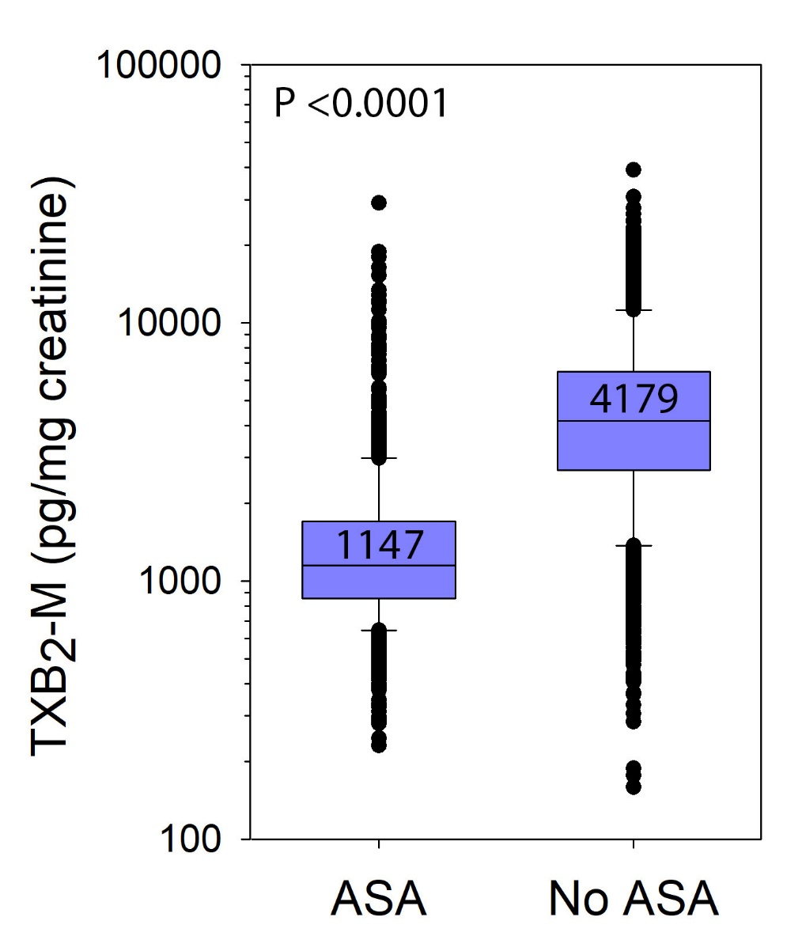

**Figure 2**

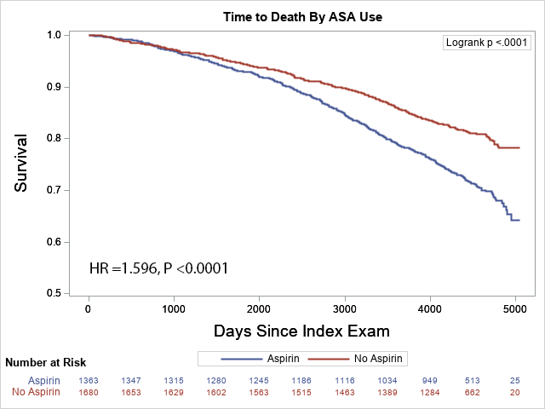

**Figure 3A**

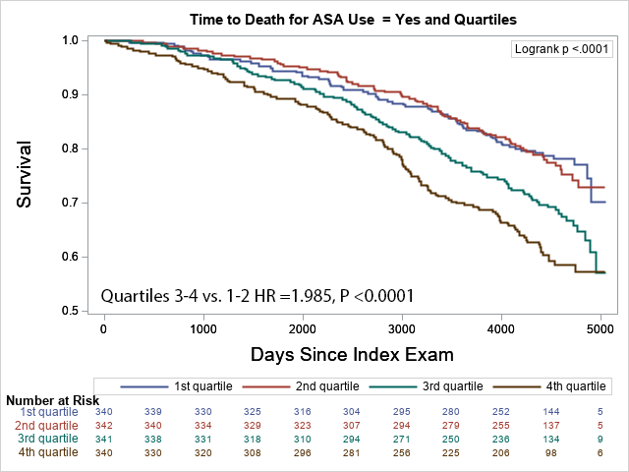

**Figure 3B**

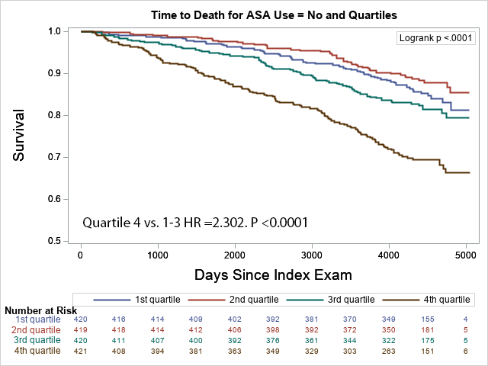

**ONLINE DATA SUPPLEMENT**

|  |  |  |  |  |  |  |
| --- | --- | --- | --- | --- | --- | --- |
| **Supplement Table 1.** Univariate linear regression analyses of the association of variables with urine TXB2-M* in aspirin users and non-users. | | | | | | |
|  | **ASA Users** | | | **ASA Non-users** | | |
| **Variable** | **N** | **Standardized Regression Coefficient** | **P-value** | **N** | **Standardized Regression Coefficient** | **P-value** |
| Age (per year) | 1363 | 0.084661 | 0.0016 | 1681 | 0.152928 | <0.0001 |
| Female gender (versus male) | 1363 | 0.143685 | <0.0001 | 1681 | 0.083353 | 0.0006 |
| Non-white race (versus white) | 1352 | 0.032402 | 0.2301 | 1651 | -0.056623 | 0.0331 |
| Hispanic ethnicity (versus non-Hispanic) | 1203 | 0.123911 | <0.0001 | 1504 | 0.025428 | 0.3244 |
| BMI (per kg/m2) | 1359 | 0.025472 | 0.3449 | 1677 | 0.045630 | 0.0617 |
| eGFR (per mL/min/1.73 m2) | 1352 | 0.127245 | <0.0001 | 1662 | 0.057184 | 0.0359 |
| Cigarette use (versus never) | 1358 |  | <0.0001 | 1681 |  | <0.0001 |
| Current |  | 0.142412 | <0.0001 |  | 0.085403 | 0.0005 |
| Former |  | 0.030349 | 0.2558 |  | 0.075534 | 0.0019 |
| LVEF (per %) | 1245 | -0.029155 | 0.3004 | 1536 | -0.023034 | 0.3670 |
| Atrial fibrillation/flutter rhythm on ECG | 1363 | 0.054589 | 0.0423 | 1681 | 0.150148 | <0.0001 |
| Medical history (versus no history): |  |  |  |  |  |  |
| Hypertension | 1363 | -0.010847 | 0.6869 | 1681 | 0.135535 | <0.0001 |
| Hyperlipidemia | 1362 | -0.064651 | 0.0163 | 1680 | 0.035628 | 0.1444 |
| Diabetes | 1357 | 0.111355 | <0.0001 | 1672 | 0.083815 | 0.0006 |
| Heart failure | 1363 | 0.027441 | 0.3080 | 1681 | 0.057835 | 0.0177 |
| Myocardial infarction | 1363 | 0.013364 | 0.6227 | 1680 | 0.073191 | 0.0027 |
| Atrial fibrillation/flutter | 1363 | 0.066042 | 0.0142 | 1672 | 0.141437 | <0.0001 |
| Cerebrovascular disease | 1363 | 0.035514 | 0.1867 | 1681 | 0.087505 | 0.0003 |
| Peripheral vascular disease | 1362 | 0.047153 | 0.0813 | 1681 | 0.002112 | 0.9310 |
| Coronary revascularization | 1363 | 0.004971 | 0.8576 | 1681 | 0.067661 | 0.0055 |
| PCI |  | -0.016742 | 0.5414 |  | 0.058074 | 0.0173 |
| CABG surgery |  | 0.017313 | 0.5242 |  | 0.047353 | 0.0522 |
| Valvular heart surgery | 1363 | -0.015799 | 0.5569 | 1681 | 0.039312 | 0.1071 |
| COPD | 1363 | 0.043062 | 0.1093 | 1681 | 0.083324 | 0.0006 |
| DVT/PE | 1363 | 0.009475 | 0.7246 | 1681 | 0.015881 | 0.5152 |
| Cancer | 1363 | -0.013559 | 0.6143 | 1681 | 0.041981 | 0.0853 |
| Medications use (versus none): | 1363 |  |  | 1681 |  |  |
| ASA dose (> 81 mg/d versus ≤81 mg/d) | 1363 | 0.129469 | <0.0001 | 1681 |  |  |
| NSAID | 1363 | -0.004733 | 0.8603 | 1681 | -0.140060 | <0.0001 |
| Antihypertensive use | 1363 | -0.004105 | 0.8788 | 1681 | 0.006897 | 0.7775 |
| Beta-blocker | 1363 | 0.004583 | 0.8657 | 1681 | 0.118753 | <0.0001 |
| ACEi/ARB | 1363 | -0.016767 | 0.5339 | 1681 | 0.047259 | 0.0527 |
| Lipid therapy (versus none) | 1363 | -0.062567 | 0.0200 | 1681 | 0.004903 | 0.8408 |
| Statin | 1363 | -0.051530 | 0.0556 | 1681 | 0.039598 | 0.1046 |
| Non-statin | 1363 | -0.015134 | 0.5737 | 1681 | -0.052546 | 0.0312 |
| Diuretic | 1363 | -0.010140 | 0.7061 | 1681 | 0.079397 | 0.0011 |
| Insulin | 1363 | 0.023885 | 0.3744 | 1681 | 0.003911 | 0.8727 |
| Non-insulin diabetic therapy | 1363 | 0.080585 | 0.0028 | 1681 | 0.069487 | 0.0044 |
| Oral anticoagulant | 1363 | 0.040608 | 0.1315 | 1681 | 0.188710 | <0.0001 |
| Laboratory data: |  |  |  | 1681 |  |  |
| Serum creatinine (per mg/dL) | 1352 | -0.171747 | <0.0001 | 1662 | -0.129675 | <0.0001 |
| Fasting plasma glucose (per mg/dL) | 1356 | 0.106507 | <0.0001 | 1671 | 0.081017 | 0.0009 |
| Hemoglobin A1C (per %) | 1355 | 0.106453 | <0.0001 | 1671 | 0.118336 | <0.0001 |
| Plasma lipid profile: |  |  |  |  |  |  |
| Total cholesterol (per mg/dL) | 1356 | -0.006613 | 0.8072 | 1672 | -0.072443 | 0.0030 |
| LDL cholesterol (per mg/dL) | 1356 | -0.038648 | 0.1525 | 1671 | -0.070515 | 0.0039 |
| HDL cholesterol (per mg/dL) | 1356 | -0.012190 | 0.6524 | 1671 | -0.082174 | 0.0008 |
| Triglycerides (per mg/dL) | 1356 | 0.075001 | 0.0053 | 1672 | 0.085082 | 0.0005 |
| Serum CRP (per mg/L) | 1351 | 0.068296 | 0.0114 | 1662 | 0.101375 | <0.0001 |
| Serum insulin (per pmol/L) | 1354 | 0.067949 | 0.0119 | 1670 | 0.114534 | <0.0001 |
| Serum MCP-1 (per pg/mL) | 1300 | 0.048542 | 0.0777 | 1605 | 0.045726 | 0.0670 |
| Serum IL-6 (per pg/mL) | 1300 | 0.113729 | <0.0001 | 1604 | 0.159307 | <0.0001 |
| Plasma P-selectin (per pg/mL) | 1356 | 0.099453 | 0.0002 | 1670 | 0.098264 | <0.0001 |
| Plasma Lp-PLA2 (per ng/mL) | 1339 | 0.010924 | 0.6873 | 1604 | 0.017394 | 0.4816 |
| Urine 8-isoPGF2α (per pg/mg creatinine) | 1362 | 0.176048 | <0.0001 | 1678 | 0.190122 | <0.0001 |
| Urine albumin-creatinine ratio (per ln mg/g) | 1362 | 0.168069 | <0.0001 | 1678 | 0.134999 | <0.0001 |
| Abbreviations: SD, standard deviation; BMI, body mass index; LVEF, left ventricular ejection fraction; ECG, electrocardiogram; PCI, percutaneous coronary intervention; CABG, coronary artery bypass graft; COPD, chronic obstructive pulmonary disease; DVT, deep vein thrombosis; PE, pulmonary embolus; ACEi, angiotensin converting enzyme inhibitor; ARB, angiotensin receptor blocker; LDL, low-density lipoprotein; HDL, high-density lipoprotein; CRP, C-reactive protein; MCP, macrophage chemotactic factor; IL-6, interleukin-6; Lp-PLA2, lipoprotein-associated phospholipase A2; IQR, interquartile range.  *Ln-transformed. | | | | | | |

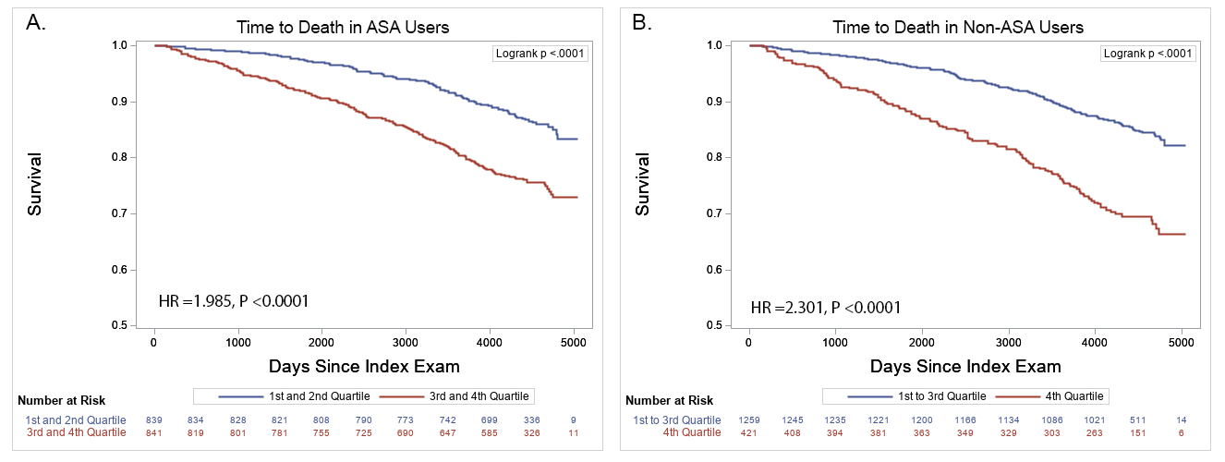

**Supplement Figure 1.** Cumulative long-term survival stratified by: A) Median of TXB2-M in ASA users (N =1361), and: B) Quartiles 1-3 versus 4 in non-ASA users (N= 1361).

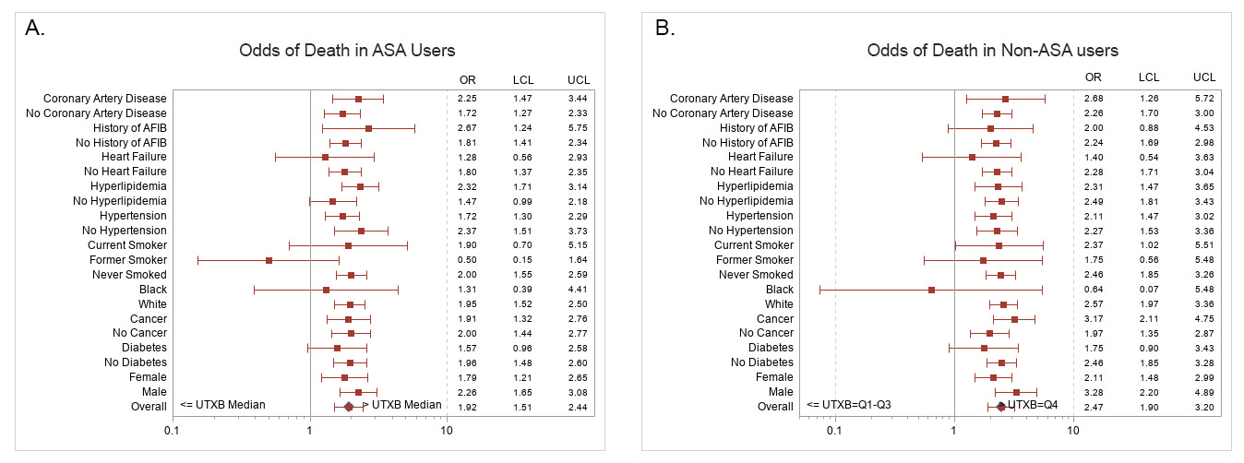

**Supplement Figure 2.** Odds ratios of all-cause mortality by presence or absence of indicators stratified by: A) Median of TXB2-M in ASA users (N =1361), and: B) Quartiles 1-3 versus 4 in non-ASA users (N= 1361).